Higher Institute of Engineering

Communication & Electronics Department

**Experiment (7): Hyrbid network**

Student Name : Abdelrahman Mahmoud Abdelrahman Mahmoud

Student Code : 125200238

Section Number : 2

Student Number in the registration statement :32

4th Computer & Control

Sec (2)

Dr/ Mohamed Abdelhamid

**192.168.16.0/24** main network

Will divide it to **4 subnets** each subnet has **64 IPs** .

The new subnet mask will **255.255.255.192** or **/26**

There will be one subnet for each floor and there will be subnet spare

**The first floor**

the range of IP will be from **192.168.16.0** to **192.168.16.63**

with **192.168.16.1** as a gateway to all devices in subnet(floor)

**Second floor**

The range of IP will be from **192.168.16.64** to **192.168.16.127** With **192.168.16.66** as a gateway to this subnet(floor)

**Third floor**

Range of IPs from **192.168.16.128** to **192.168.16.191**

With **192.168.16.130** as a gateway to this subnet (floor)

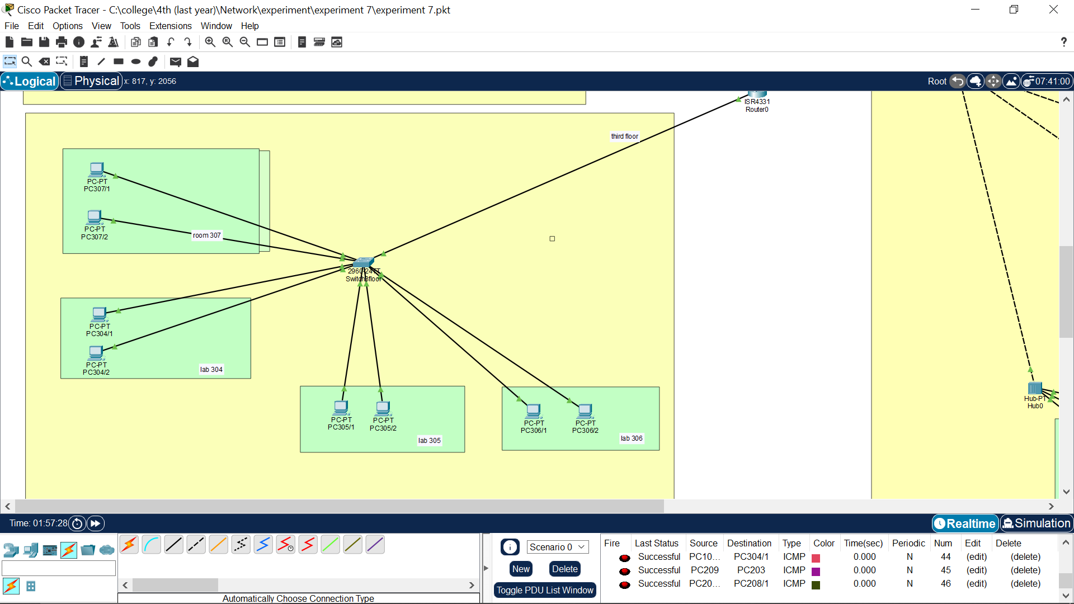

**All of these networks connected to access switch and each access switch is connected to distributed switch to connect all these floor with each others.**